Body Fat Percentage Electronic Analyzer

| Ellen Robertson  Electrical and Computer Engineering  North Carolina State University  eerobert@ncsu.edu | McKenzy Heavlin  Electrical and Computer Engineering  North Carolina State University  mdheavli@ncsu.edu | Colt Nichols  Electrical and Computer Engineering  North Carolina State University  cwnicho2@ncsu.edu |
| --- | --- | --- |

| Priya Jakhar  Electrical and Computer Engineering  North Carolina State University  pjakhar@ncsu.edu | Katherine Lawhorn  Electrical and Computer Engineering  North Carolina State University  kalawhor@ncsu.edu |
| --- | --- |

***Abstract–*While maintaining a healthy weight is important, many people neglect something more important, which is what composes that weight. Body composition refers to the proportion of fat and lean tissue like muscles, bone, body water, organs in the body. There are many scales and devices available on the market that allow people to check their weight or body fat percent. Devices like skinfold calipers, body circumference and bioelectrical impedance analysis scales are available for use at home while more sophisticated methods like ADP(Air Displacement Plethysmography), hydrostatic weighing, dual-energy X-ray absorptiometry are only available in medical or testing facilities. Most devices for home usage are difficult to use or inaccurate so we decided to develop an inexpensive, easy to use and accurate device for measuring body fat percentage. Our device performs Bioelectrical Impedance Analysis (BIA) which is a method for calculating body composition using low level electrical current. Based on user information like gender, age and weight, the device calculates their body fat percentage by measuring the voltage drop through their body. Our device was validated in order to confirm BIA calculations and voltage changes.**

***Index terms* – Arduino Nano, Accuracy, Body Impedance Analysis**

1. INTRODUCTION

Bioelectrical impedance analysis (BIA) is an underused and underestimated tool used to measure body composition. Unlike Body Mass Index (BMI) that is used in many doctor’s offices, BIA can be used to measure body fat percentage by measuring the lean body mass. It can also provide information on fluid content. This information is a better representation of a person’s nutritional state and muscle mass rather than a BMI measurement [1]. Therefore, BIA is a useful tool for all people to help determine the overall balance of the body.

BIA is a non-invasive method that uses bioelectrical impedance vector analysis (BIVA) to measure body fat percentage. BIA works by using the electric impedance of an electrical current generated at a fixed frequency that is propagated through the body via electrodes [1]. This current passes through the body and the voltage drop is measured through electrodes. Because the body has different types of tissue, the flow of current is affected by the amount of water and the impedance. For example, tissues that contain large amounts of fluid and electrolytes have high conductivity and do not slow the electrical signal down. However, fat and bones slow the electrical signal down, which results in a voltage drop. By determining the resistance to the flow of the current, body fat percentage can be calculated.

Body fat percentage, the information obtained from BIA analysis, indicates the percent of fat present in the body. It is a better indicator of overall health rather than the standard weight as it takes into account body composition. A higher body fat percentage can be an indicator of an increased risk of potential life altering diseases such as diabetes and heart issues [2]. Also, there is a linear relationship between body fat percentage to morbidity and mortality as discussed in Bӧhm and Heitmann. Based on this information, it is important to monitor body fat percentage.

Current tools on the market for at home BIA analyzers are not accurate and easy for people to understand [3]. They are also extremely sensitive to many normal factors. For example, BIA analysis could be less accurate if a subject drinks water before the test or even uses the restroom. Therefore, there is a market need to create a better BIA analyzer that is more accurate and less sensitive to outside factors.

1. STATEMENT OF PROBLEM

There are numerous existing technologies to measure body fat that individuals have access to at home, local gyms, or private facilities. These tools all use different technologies and formulas to estimate a user’s body fat. Understanding the current technologies will help uncover potential problematic measurement methods. Several methods have been researched below such as: skinfold calipers, body circumference measurements, hydrostatic weighing, and BIA scales. These were chosen by popularity and accessibility.

1. *Skinfold Calipers*

In this method, a caliper is used to measure body fat in two to nine locations around the body [4]. These measurements are then summed to give a total estimate of body fat. (1) and (2) have been reported [5] to relate percentage body fat as a function of the sum of the skinfold measurements.

Skinfold equation for males using four measurement locations, where the skinfold sites, measured in millimeters, are the abdominal, triceps, thigh, and supra-iliac.

*% Body Fat = (0.29288 * sum of skinfolds)*

*– (0.0005 * square of the sum of skinfolds)* (1)

*+ (0.15845 * age) – 5.76377*

Skinfold equation for females using four measurement locations, where the skinfold sites, measured in millimeters, are the abdominal, triceps, thigh, and supra-iliac.

*% Body Fat = (0.29669 * sum of skinfolds)*

*– (0.00043 * square of the sum of skinfolds)* (2)

*+ (0.02963 * age) + 1.4072*

1. *Body Circumference Measurements*

The body circumference measurement method of estimating body fat relies on measuring an individual’s body circumference at various points around the body, most commonly the waist. According to the CDC [6], the following steps will correctly measure waist circumference:

1. Stand and place a tape measure around your middle, just above your hip bones
2. Make sure tape is horizontal around the waist
3. Keep the tape snug around the waist, but not compressing the skin
4. Measure your waist just after you breathe out

While these measurements can be insightful about your body health, they should not be used as a “diagnostic of the body fatness or health of an individual” [6].

1. *Hydrostatic Weighing*

Hydrostatic weighing is considered to be “a reliable and accurate technique” [7] used to measure body fat percentage. The method relies on weighing an individual inside and outside water, the subject's weight fully submerged under the water, the density of the water, and the volume of water displaced. The body density can then be calculated using a standard formula.

Once the body density has been calculated, the percent body fat can then be calculated using either of the following methods:

Siri [8]:

% Body Fat = $(\frac{495}{Body Density}-450)×10$ (3)

Brozek [9]:

% Body Fat = $(\frac{4.570}{Body Density}-4.142)×100$ (4)

The equation used for this process is determined by the study group and what is most appropriate for their characteristics.

1. *BIA Scales and Handhelds*

Bioelectrical impedance analyzers, like the device shown in Fig. 1, have gained popularity with the public, primarily in the form of scales and handheld devices. These devices operate by sending a weak electrical signal through the body which experiences impedance from the body. The device uses a mathematical model to equate the impedance measurement to various body percentages such as muscle, total fat, and water. This is possible based on the properties of various biological components, i.e. fat has more resistance than water or muscle.

Through analyzing how these technologies work, it can be determined that variables such as gender, weight, height, and age are important in calculating body fat. The technologies tend to rely on generating lots of data, performing a linear regression, and creating a formula which works for the general population. These tools differ in their method of collecting data. The next section will explore the accuracy of these different methods as well accessibility.

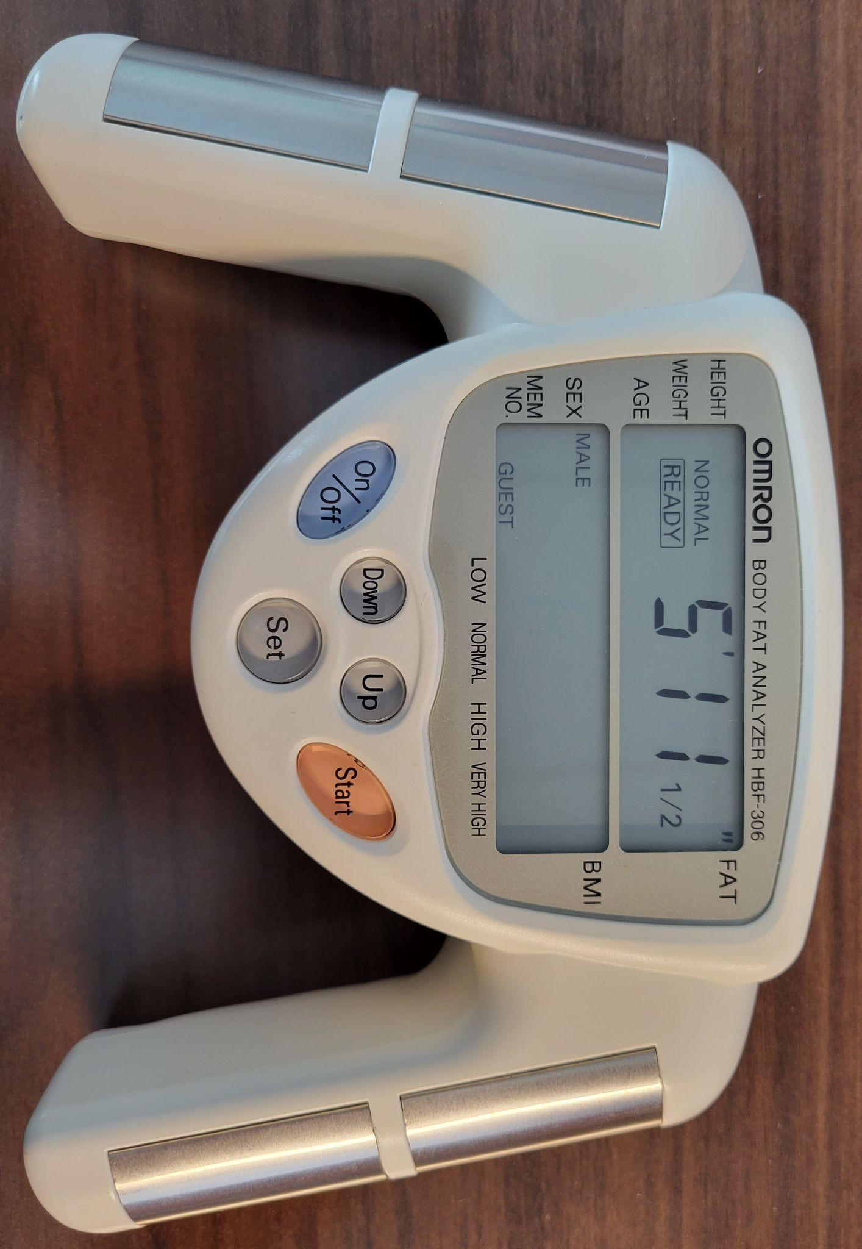

Fig. 1. The Omron Healthcare Body Fat Analyzer which outputs a user’s body fat percentage and body mass index based on their height, age, weight, and sex.

1. CONCEPT DEVELOPMENT
2. *Analyzing Body Fat Measurement Technologies*

In this section, the constraints of each previously mentioned method are explored. Factors such as accessibility and accuracy play an integral role in determining which method works best for general public usage.

* 1. *Skinfold Calipers*

While skinfold calipers are cheap and easily accessible, they are inaccurate, mostly due to poor self-administration. This includes how accurately the proper skinfold sites are identified and located, the placement technique, accessibility of site to be measured and time passed before taking results. Without proper training, inconsistent measurements can be taken, lowering the accuracy of skinfold calipers. For better understanding, DXA (Dual-Energy X-Ray Absorptiometry) is regarded as the gold standard for measuring body fat. In a study comparing the accuracy of a digital and self-administered skinfold caliper to DXA on college-aged men and women [10], the skinfold calipers were ultimately not recommended for use to measure body fat.

* 1. *Body Circumference Measurements*

Like skinfold calipers, taking body circumference measurements are cheap and easily accessible; moreover, self-administered measurements are generally as accurate as a trained clinician. The inaccuracy of this method lies in the equations used to calculate body fat. The equations disregard differences in fat distribution and body shape. For example, women generally have more body fat percentages and are shorter than men. A study [11] examines this by specifically comparing body adiposity index (BAI), calculated using (5), to DXA.

BAI Equation

$BAI = \frac{hip circumference}{18*({height)}^{1.5}}$ (5)

BAI does not include a person’s sex or weight. The study concluded that error is present when done without regard to sex and people with higher body fat percentages [11].

* 1. *Hydrostatic Weighing*

Another explored method of calculating body fat percentage is hydrostatic weighing. While accurate, this method is not generally open to the public. It is usually found in research or fitness facilities. Hydrostatic weighing also requires the person to be fully submerged underwater which discriminates against some people with disabilities. With a purpose of distributing body fat measuring tools to the general public, hydrostatic weighing is an unrealistic method.

* 1. *BIA Scales and Handhelds*

Current BIA technologies widely accessible to the public include BIA scales and handhelds. In creating a BIA device, the potential shortcomings of these BIA devices need to be examined as well. One of the most accurate BIA scales (98% accurate) is the InBody 270 Body Composition Analyzer. Due to the high cost, this machine is used mainly by professionals. A study [12] measured the accuracy of the InBody 270 in children 10-12 years old and concluded that there are inaccuracies in profiling body composition in children of different sex. Even one of the most accurate BIA scales on the market can not be effectively used to measure all demographics of the general public.

After analyzing the shortcomings of existing technology on the market, inaccuracies are often found. Formulas which do not account for enough variables like age and gender or improper self-administration are likely behind these inaccuracies. While BIA technology is not perfect, it is the best body fat measuring technology when accounting for price, accessibility, and accuracy. The goal is to create a cheap, accessible BIA measurement tool which will take all relevant variables into account: age, weight, and gender. BIA leaves little room for self-administration error and grants great insight into the muscle/fat composition of the user.

1. *Concept for Electrical Analysis*

The cellular material that constitutes the body can be modeled electrically as a combination of resistances and capacitors. This model accounts for the resistance of the intracellular and extracellular fluids (RI & RE), and the membrane capacitance (Cm), as shown in Fig. 2. Due to this structure, the tissue exhibits varying impedance based on the frequency of the AC current applied. The impedance behavior is also affected by the tissue make-up making it possible to measure body fat percentage electrically [13,14].

Fig. 2. Circuit equivalent of cellular material that constitutes the body which is composed of intracellular and extracellular fluids (Ri and Re) and the membrane capacitance (Cm).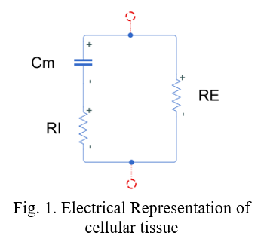

Our approach was to develop a microcontroller based platform to measure body fat by leveraging the properties mentioned above. As shown in the signal flow chart in Fig. 3, we planned to use the controller to apply a small AC current to the body (10s of μA) and measure the resulting voltage between surface electrodes. This significant current restriction during BIA analysis is critical for the safety of the user [13]. Due to the small amplitude of signals, we also must electrically isolate the signal at multiple points of the process.

Fig. 3. Flow chart for the measurement signal through the body.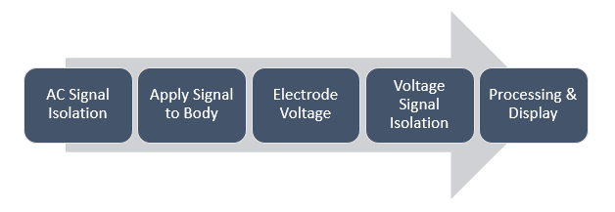

To conduct the BIA measurement, our device’s electrodes are placed on the hand and foot of the subject to apply the necessary micro current and measure the resulting voltage. This experimental setup can be seen in Fig. 4. Due to the nature of bioelectrical impedance, the location of these electrodes could be altered to achieve different goals, such as calculating the localized body fat of an area, or just to make a handheld that requires less wiring. Since our efforts in this project were developmental, we utilized the typical electrode layout so we may reference existing BIA experiments as needed for guidance [14,15].

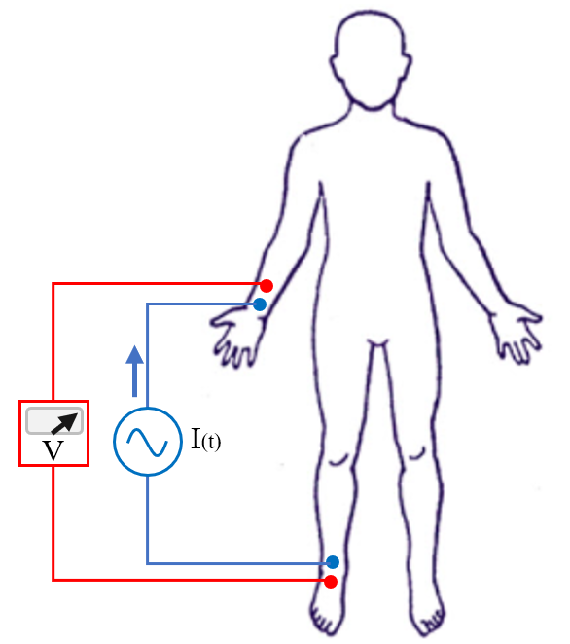

Fig. 4. Simplified diagram representing the current source and voltage reader in relation to the electrode placement on the wrist and ankle.

1. DESIGN PROCEDURE AND PROTOTYPING
2. *Circuit Schematic*

One of the critical first steps was the creation of our circuit schematic. To do this we used computer software to assist in the detection of errors in our design, and to allow for rapid revisions of our prototype. We studied several references in order to formulate our schematic [13,14,15] and the design we implemented in our project is shown in Fig. 5.

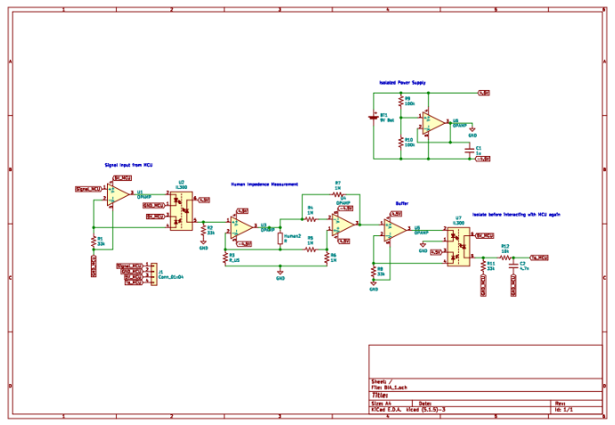

Fig. 5. Initial circuit schematic to measure bioelectrical impedance.

Due to the inherent complexity of this circuit, the full resolution of this and our other works is submitted along with our report in our “Design and Implementation” file. Please refer to that if the image above is not clear in the form you are viewing this report. The concept behind our circuit is to analyze the body as a device of electrical impedance (as previously mentioned in concept development). From that electrical behavior we can render a body fat estimation based on our regression formulas relating biological information to electrical characteristics.

The schematic from left to right involves a buffering and isolation step between the stimulation signals and the subject, then a measurement and amplification step. This is where our circuit interfaces with the human body. Then another buffer and isolation step to pass the results back to the microcontroller for processing and displaying results on the LCD screen. The upper right area of the schematic is a small circuit to create an isolated power supply for the circuitry that interfaces with the subject’s body, and is included for safety reasons.

1. *Initial Circuit Iteration*

After designing the circuit, a bread board was used to develop the iso-coupled circuit with amplifiers–as seen in Fig. 6. An isolated power supply with a 9V battery as the source was soldered onto a PCB board and was used in order to prevent current overdraw.

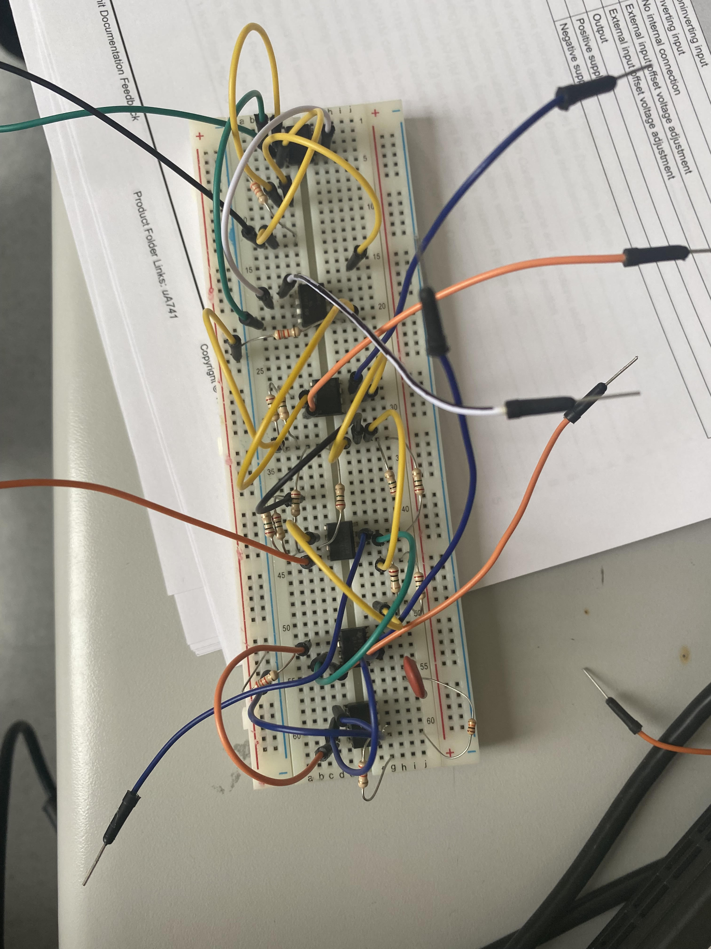

Fig. 6. Circuit implementation of the schematic shown in Fig. 5.

The placement of the electrodes was researched as it is vital for the proper estimation of body fat percentage. Two electrodes were used to study the voltage change. We chose the inside of the wrists and the outside of the ankle as seen in Fig. 7. This makes the current flow from on one side of the body from wrist to ankle. The device interprets the change of voltage from the electrodes. It then uses a formula, that we developed, to calculate the body fat percentage.

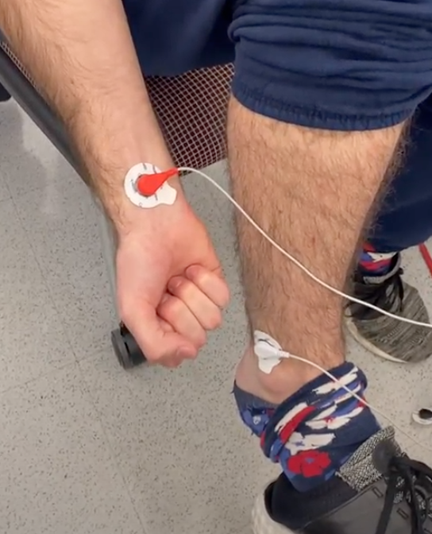

Fig. 7. Electrode placement on wrist and lower ankle.

1. *Packaging*

Initial packaging was developed in order to ensure the prototype was portable and easy to use. The packaging was 3D printed using a Markforge printer with black Onyx material. The edges of the packaging were fileted to ensure there were no sharp edges. The size was also minimized to ensure that the device was portable. Once printed, the exterior dimensions of the packaging were 6.75in (length) by 4.5in (width) by 1in (height). This allowed the arduino and the bread board to fit inside the packaging. The overall packaging can be seen in Fig. 8.

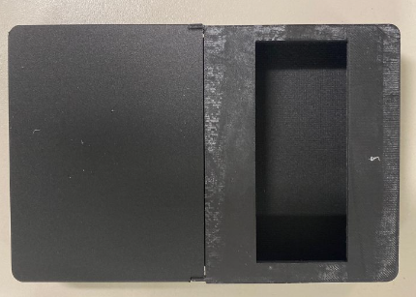

Fig. 8. 3D printed packaging for the device with area for LCD monitor for easy use and display of measurements. The length and width of the packaging are shown on the figure and the height is 1in.

The packaging is split into two parts. There are four pegs on the upper part and it contains the opening for the LCD. The lower part has the holes for the pegs which serve as the interconnects. There are also slots for the arduino USB cable and the electrodes. Fig. 9 shows the USB and electrodes slots.

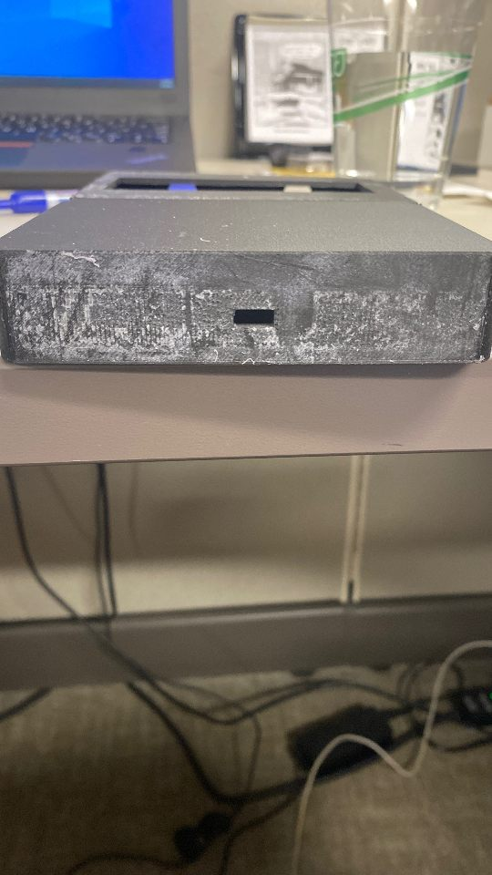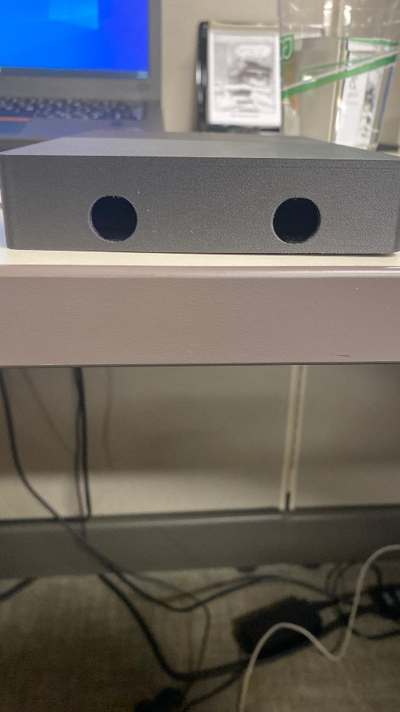

Fig. 9. (a) Slots for the USB cable, (b) slots for the electrodes.

1. *Code*

The first draft of code only produces the signal that is fed to the input electrode through the isolation circuit and then displays the analog voltage value measured on the other end of the circuit after the signal has passed through the body and fed back into the isolation circuit through the other electrode. It is necessary to measure analog voltage while simultaneously producing the input signal because the microcontroller operates at a high clock frequency of 16 MHz and if we tried to read the analog voltage value after having produced the input signal, it will record 0 value as the signal has dissipated by that point in time. For ADC conversion, the arduino uses the main clock frequency divided by a prescale factor. The default value of the prescale factor is 128 which only gives us 16MHz/128 = 125 KHz ADC clock frequency. ADC conversion takes about 13 ADC cycles so we get a maximum speed of 9600 Hz (125KHz/13) which is too low for our application. So we had to modify the default scaling factor down to 16 which gives a sampling rate of 76.8 KHz and allows us to use the convenient analogRead function of the Arduino. The code flow diagram is shown below in Fig. 10.

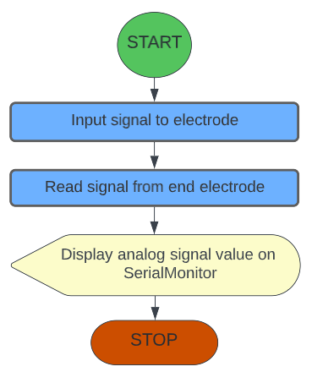

Fig. 10. Flow diagram for the first draft of Arduino code

1. EXPERIMENTAL RESULTS
2. *Validation of Circuit*

The prototype of the circuit was tested in multiple ways to ensure that it was functioning properly. The first validation test used a 620kΩ resistor to stimulate the average resistance of a human body. Change was observed between the input signal from the microcontroller and the output of the circuit, demonstrating the resistance has an effect on the output. The image of the output of the circuit is shown below in Fig. 11.

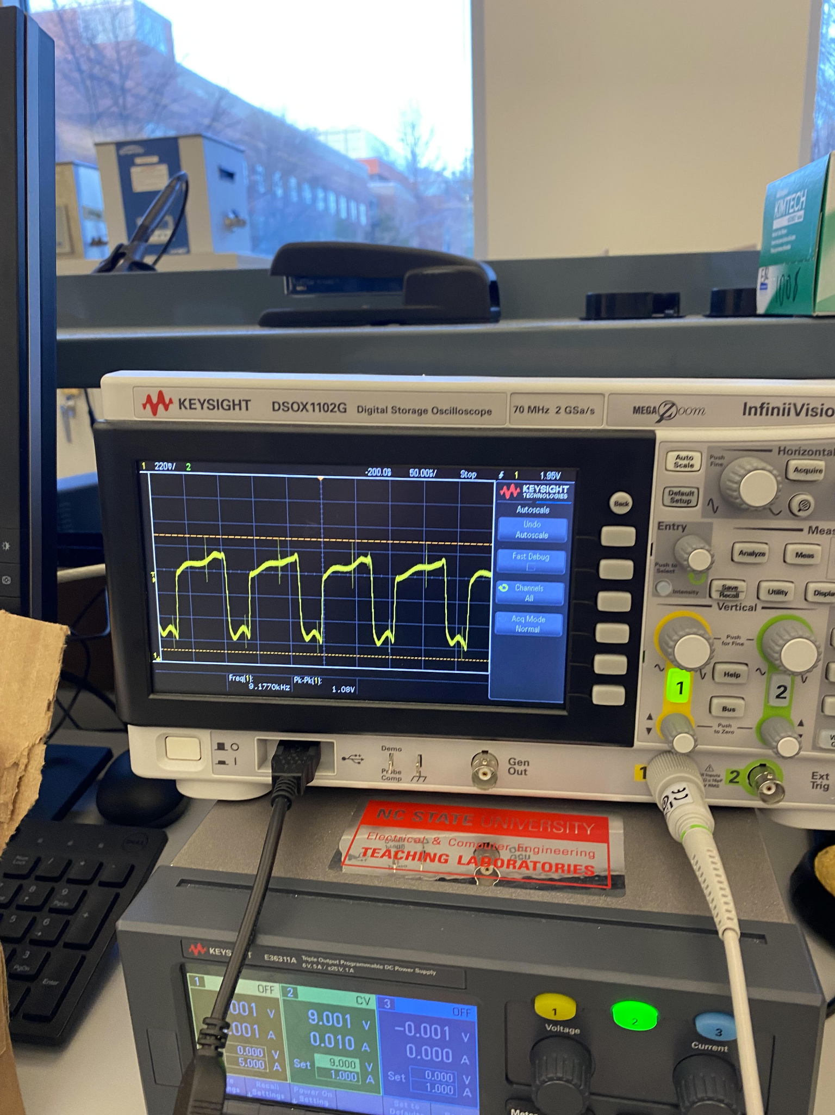

Fig. 11. Output of the circuit from the 630kΩ resistor.

Validation testing was also performed on group members in order to determine the reproducibility of the results from the earlier circuit. Each participant was wired with electrodes and the microcontroller was used to send input signals via the circuit. The voltage values measured by the microcontroller were displayed on the SerialMonitor. This test was performed five times on each participant to ensure the analog output was within a .2 Volt range each time. This test confirmed that the resistance varied from person to person, demonstrating that the circuit was sensitive to different impedances. The test also confirmed that the analog output was reproducible, demonstrating an accurate reading of the output voltage.

1. *MATLAB Regressions*

The next task was creating a mathematical model that related the analog reading received from the circuit and an individual’s body fat percentage. Due to the differences in body fat percentage for different genders, two models were needed to properly represent the relationship. The MATLAB multivariate linear regression function, mvregress(), was used to help create the model. This function takes in two matrices, X and Y, and returns estimated coefficients for each independent variable using a multivariate normal regression. The X matrix, a *n*-by-3 matrix, contained the age, weight, and analog reading, where *‘n’* is the number of data points collected. The Y matrix, a *n*-by-1, contained the body fat percentage readings from the Omron Healthcare Body Fat Analyzer for *‘n’* number of data points. For the male body fat model, there were 13 data points collected from the male members of our group. For the female body fat model, there were 21 data points collected from the female members of our group. Using these data points with the mvregress function, equation (7) and (8) were obtained:

*Male Body Fat % = (–0.29669 * age)*

*+ (0.3624 * weight)* (6)

*– (0.0078 * analogReading)*

*Female Body Fat % = (–0.0698 * age)*

*+ (0.1415 * weight)* (7)

*– (0.002 * analogReading)*

To check if these equations were giving appropriate body fat percentages, members of the team measured their percent fat on a different day and compared those values to the output of the Omron Healthcare Body Fat Analyzer. The values and variation in the measurements found during the tests were consistent with other body fat percentage devices which support the initial quality of the derived relationships.

1. *LCD Code*

The final code takes inputs from the user like their gender, age and weight (in lbs) through the SerialMonitor of Arduino in the specific format of “<gender,age,weight>”. After it has received inputs from the user, it produces the signal to be sent through the input electrode while simultaneously measuring the analog voltage on the other electrode. An overview of the flow chart for this finalized LCD code is shown in Fig. 12. After about 3 seconds, the program calculates the body fat percent of the user, choosing the formula to use based on their gender. Once the body fat is calculated, it is displayed on the LCD as seen in Fig. 13.

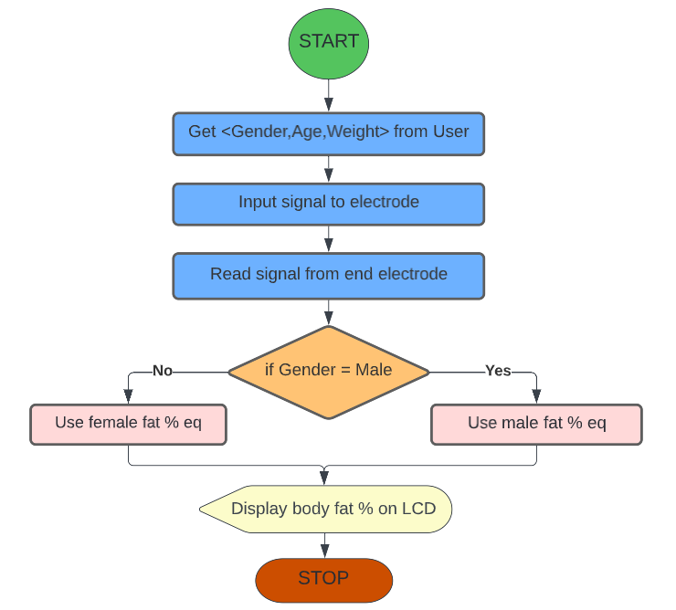

Fig. 12. Flow Diagram for Analysis of Body Fat Percentage Device

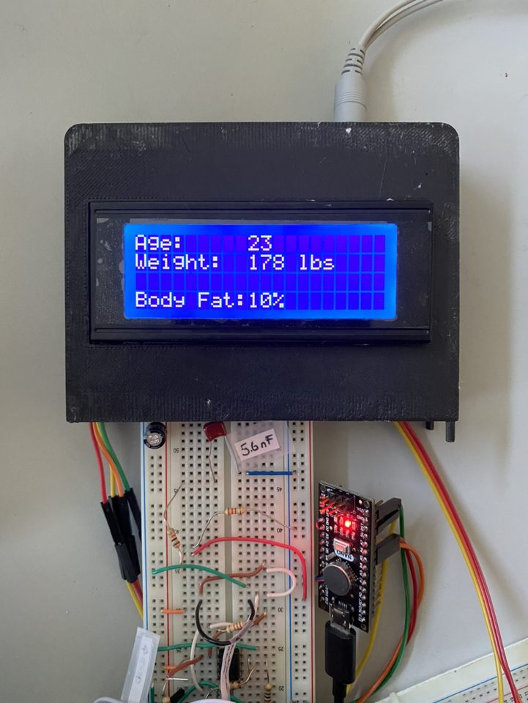

Fig. 13. Final implentation with output on the LCD

1. FUTURE WORK
2. *MATLAB Regressions*

It is important to note the small data set utilized to derive the relationships between the analog output, age, weight, and body fat percentage. Additional testing and measurements for both males and females would increase the accuracy of the device and provide better mathematical models that could be used to find body fat percentage.

1. *Printed Circuit Board*

In the later stages of our project, we developed designs for a printed circuit board (PCB) that would include the revisions/corrections we made along the way. This board could be ordered and serve as an equivalent to all the breadboard components and represents a significant reduction in the size of our device. Even still, this PCB was designed using through-hole components instead of even smaller surface mount packages often used when electronics are manufactured. This makes it feasible for a group of students like ourselves to populate (solder the components onto) the board with hand solder irons. Thus the device could be even smaller if considering this device’s potential as a consumer product. The board design and a 3D render is shown below in Fig. 14 and Fig. 15.

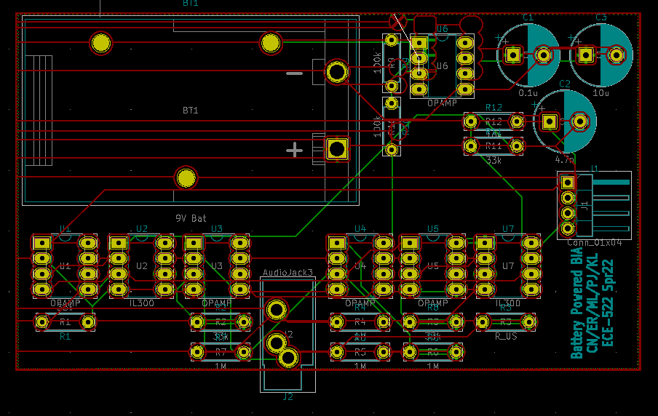

Fig. 14. Routing topology for the printed circuit board

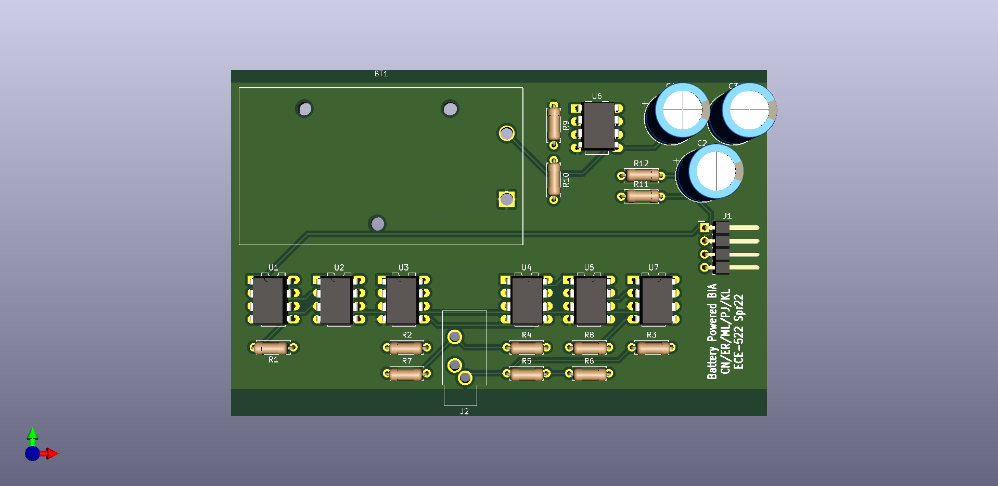

Fig. 15. 3D model of the PCB, populated with components (upper left quadrant is reserved for 9V battery holder. Area is approximately 3.5” by 2”).

1. CONCLUSION

Over the course of this project, we were able to review the current methods of bioelectrical impedance analysis and how each method is used to calculate an individual’s body fat percentage. From this analysis, it was clear that most methods varied in terms of accuracy or were inaccessible to the general population due to the expensive resources utilized.

Our solution of a lightweight, accurate and easy to use BIA device allows individuals to easily connect to the device, input their gender, age and weight, and receive their body fat percentage. Our current design, and future developments proposed offer a clean and compact packaging structure to house the electronics, arduino, and LCD monitor that is intuitive and simple to operate. Our device utilizes a unique mathematical regression to equate an individual’s gender, age, weight, and voltage drop to their body fat percentage, with the ability to update the equation with more data points to ensure increased accuracy. Overall, the solution proposed offers the flexibility and scalability necessary for an accurate, at-home, easy to use bioelectrical impedance analysis device.

REFERENCES

[1] A. Walter-Kroker, A. Kroker, M. Mattiucci-Guehlke, and T. Glaab, “A practical guide to bioelectrical impedance analysis using the example of chronic obstructive pulmonary disease,” *Nutrition Journal*, vol. 10, no. 1, 2011.

[2] A. Böhm and B. L. Heitmann, “The use of bioelectrical impedance analysis for body composition in epidemiological studies,” *European Journal of Clinical Nutrition*, vol. 67, no. S1, 2013.

[3] Wells JCK, Fewtrell MS, "Measuring body composition," *Archives of Disease in Childhood*, vol.10, no. 1, 2006.

[4] “Simple measures - skinfolds,” *DAPA Measurement Toolkit*. [Online]. Available: https://dapa-toolkit.mrc.ac.uk/anthropometry/objective-methods/simple-measures-skinfolds. [Accessed: 14-Feb-2022].

[5] A. S. Jackson and M. L. Pollock, “Practical assessment of body composition,” *The Physician and Sportsmedicine*, vol. 13, no. 5, pp. 76–90, 1985.

[6] “Assessing your weight,” *Centers for Disease Control and Prevention*, 17-Sep-2020. [Online]. Available: https://www.cdc.gov/healthyweight/assessing/index.html#:~:text=Waist%20Circumference,-How%20To%20Measure&text=Stand%20and%20place%20a%20tape,just%20after%20you%20breathe%20out. [Accessed: 14-Feb-2022].

[7] “Hydrostatic underwater weighing,” *DAPA Measurement Toolkit*. [Online]. Available: https://dapa-toolkit.mrc.ac.uk/anthropometry/objective-methods/hydrostatic-underwater-weighing. [Accessed: 14-Feb-2022].

[8] W. Siri, “Body Composition From Fluid Spaces And Density: Analysis Of Methods,” *Lawrence Berkeley National Laboratory*, LBNL Report #: UCRL-3349, 1956, Retrieved from https://escholarship.org/uc/item/6mh9f4nf.

[9] J. Brožek, F. Grande, J. T. Anderson, and A. Keys, “Densitometric analysis of body composition: Revision of some quantitative assumptions*,” *Annals of the New York Academy of Sciences*, vol. 110, no. 1, pp. 113–140, 2006.

[10] J. R. Beam and D. J. Szymanski, “Validity of 2 skinfold calipers in estimating percent body fat of college-aged men and women,” *Journal of Strength and Conditioning Research*, vol. 24, no. 12, pp. 3448–3456, 2010.

[11] D. S. Freedman, J. C. Thornton, F. X. Pi-Sunyer, S. B. Heymsfield, J. Wang, R. N. Pierson, H. M. Blanck, and D. Gallagher, “The body adiposity index (hip circumference ÷ HEIGHT1.5) is not a more accurate measure of adiposity than is BMI, waist circumference, or hip circumference,” *Obesity*, vol. 20, no. 12, pp. 2438–2444, 2012.

[12] M. N. Larsen, P. Krustrup, S. C. Araújo Póvoas, and C. Castagna, “Accuracy and reliability of the inbody 270 multi-frequency body composition analyser in 10-12-year-old children,” *PLOS ONE*, vol. 16, no. 3, 2021.

[13] S. Khalil, M. Mohktar, and F. Ibrahim, “The theory and fundamentals of bioimpedance analysis in clinical status monitoring and diagnosis of diseases,” Sensors, vol. 14, no. 6, pp. 10895–10928, Jun. 2014.

[14] P. Li and S. Borle, “Bioelectrical body fat analyzer (ECE 4760: Final Project),” *ece.cornell.edu*. [Online]. Available: https://people.ece.cornell.edu/land/courses/ece4760/FinalProjects/f2014/smb435_pkl25/webpage/index.html. [Accessed: 07-Feb-2022].

[15] D. S. Alhuwaid, A. Alqahtani, and A. Aloufi , “Bioelectrical Impedance Analyzer,” *https://www.pmu.edu.sa/*, May-2019. [Online]. Available: https://www.pmu.edu.sa/attachments/academics/pdf/udp/coe/dept/ee/senior%20design%20projects/smart_cleaner_report.pdf. [Accessed: 07-Feb-2022].